



***Digital Canvas Project Proposal***

***11 August 2014***

Team Details

|  |  |  |  |
| --- | --- | --- | --- |
| Name | Major | Role | Contact Info |
| Evan Martin | Software Development | Project Leader | [evanmnz@gmail.com](mailto:evanmnz@gmail.com)  0272529779 |
| Ben Liang | Software Development | Software Developer | [benliangforloop@gmail.com](mailto:benliangforloop@gmail.com)  02102846138 |
| Alastair Bowie | Software Development | Quality Assurance | [alastairbowie94@gmail.com](mailto:alastairbowie94@gmail.com)  0211841043 |
| Pio Kim | Software Development | Researcher | [beo1597@gmail.com](mailto:beo1597@gmail.com)  021250839 |

Stakeholders

|  |  |  |  |
| --- | --- | --- | --- |
| Andrew Colarik |  | Project Supervisor | acolarik@hotmail.com |
| Matthew Martin |  | Client | [martyfly.ta@gmail.com](mailto:martyfly.ta@gmail.com) |
| Nolwenn Lacire |  | Stakeholder - Digital Art Live Program curator at Aotea Center | [nolwennL@aucklandlive.co.nz](mailto:nolwennL@aucklandlive.co.nz) |

Table of Contents

Client Introduction 4

Project Overview 4

Scope & Objectives 5

Rock Solid Stability 5

Intuitive interaction 5

Gesture handling 5

Immersive / Creative 5

Outside of project scope 5

Project Approach 6

Methodologies 6

Kanban - Storyboard scheduling system 6

Scrum - Standup meetings 6

Single Semester Provisions 7

Development platform 7

Deliverables 8

Software Product 8

Skills and Knowledge 9

Costs 10

Hardware / Software 10

Risks and Solution 11

Project Plan 11

Other academic commitments 11

Sickness 11

AUT Research & Development Project Disclaimer 13

Appendix 14

Known software bugs 14

Client Meeting Q/A 14

# Client Introduction

Matthew Martin is a Digital Media Artist with a Bachelor’s Degree in Creative Technologies who is currently taking his masters in Creative Technology at AUT. Matthew has been involved in numerous projects that have been displayed at exhibitions and conferences. One example of Matthews’s projects, Shadow Showdown has been published in Creativity and Cognitions in 2013.

# Project Overview

The Digital canvas project is designed to be used as a interactive art installation for the Auckland Live exposition at the Aotea Centre. All ages have access to the installation. The customers who comes to the theatre are the largest part of the demographics. Other venues are being considered. The project requires easy instruction that all ages can interact with the software. The public will intuitively interactive with the canvas using gestures to explore and mask areas of a live video feed of a performance happening on the theatre stage. Each interaction will record a video, which is then moved and looped on the canvas, thus, creating a collage of overlapping videos.

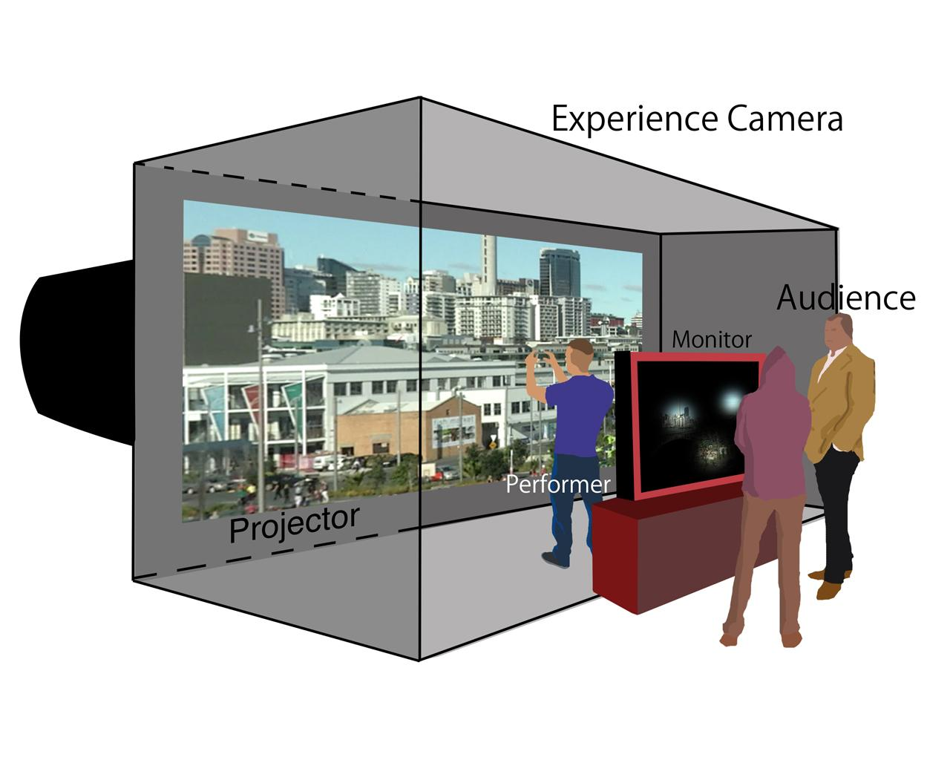

Currently there is a working prototype of the virtual canvas which has three major limitations. First, only two gestures are implemented. These gestures are the ability to mask the canvas using both hands to adjust the size, and the ability to move the mask around the canvas using one hand. Second the interface isn’t intuitive, the user has little feedback to acknowledge their interaction and has no cues to what gestures are available to use. Finally there are a number of technical issues to fix regarding stability, and gesture detection accuracy.

The technical implementation uses a Microsoft Kinect to capture a 3D image of the user, a standard web camera which is then used to record a live performance, and a Mac computer running OpenFrameworks to handle gestures and video recording.

# Scope & Objectives

## 

## Rock Solid Stability

The live installation will run continuously for three months without any technical expert’s onsite to fix issues. For this reason making the system stable is very high priority.

* Provisions to safely reboot system and automatically start software in case of power failure or unexpected crash
* Address limitations to storage space, and parallel video playback by imposing hard limits within the software
* Implement a bug tracking system to record and track bug fixes

## Intuitive interaction

The digital canvas will be used by a public of all ages without any prior training. Ideally Interacting with gestures should feel natural and not require any on screen help.

* Improve user feedback to acknowledge their interaction
* Add cues/hints for available gestures
* Usability testing

## Gesture handling

The current 3D detection algorithm is very basic with low sensitivity, improvements need to be made here to insure a seamless user experience.

* Considerations for multiple actors
* Differentiation between body parts - identified user hands rather than the first two blobs to enter the scene

## Immersive / Creative

The digital canvas is meant to be a platform to create digital art, additional features will be explored to allow more creative freedom for the user.

* Additional gestures
* Enhance video layering and opacity settings

## Outside of project scope

* Live hardware installation and operations

# Project Approach

## Methodologies

Because the project requirements are likely to change after our research and usability testing phase we have elected to pick various agile activities to support the development process.

### Kanban - Storyboard scheduling system

Kanban is an agile method for managing workflow. It uses a physical storyboard with user stories in columns such as backlog, in-progress, testing, finished. The user stories are moved across each column as that task is completed. Each column has a limit, which means user stories are completed in their entirety before moving on enabling faster production of tangible work without wasting overhead planning far into the future.

Our main reason for selecting Kanban as our planning tool is because it allows us to attack the highest priority stability issues first without the upfront overhead of a Gantt chart or similar method.

### XP - Peer programming

Peer programming is simply when two developers sit side by side and work on code. The advantage is there may be a synergy using two developers because of the combined knowledge allows for faster programming and higher quality.

To ensure the project stability is rock solid, we need to high code quality so peer programming should be beneficial.

### Scrum – Stand-up meetings

Stand-up meetings are an efficient method for running meetings. Each day a 5min meeting will be held between the developers and sometimes the client. Three questions are asked, what did you work on? What will you work on next? Do you have any issues? This allows for frequent communication between the team and the client without high overhead.

## Single Semester Provisions

Evan Martin has been accepted for a single semester project. In order to work with a team who has longer timeline he will focus primarily on stability issues, as these can be addressed in parallel to the other developers who will be creating a more immersive and intuitive user experience.

## Development platform

The current prototype is setup in WG1000 colLab, this poses an issue as we are unable to get regular access to this room. Ideally a machine will be setup inside one of WT project labs. The client will be providing a Microsoft Kinect camera for motion capture and a regular webcam for the source video. We have already been sent the development code, and just need to install the required software and import the project code. The only issue here is that the software is not multiplatform and must be run on a Mac computer which has a dedicated graphics card as the software leverages this to process the video streams.

# Deliverables

## Software Product

Our primary deliverable is a stable version of the source code and finalized compiled software. We already have the source code from the client, and we will incrementally release stable versions to the client. With each stable release we will compress the source code and compiled version as a zip file and email it to the client. This will show the client our progress continually and make sure we are on the right track.

## Quality Assurance

Quality is an important factor when it comes to a product. In order to maintain or enhance the quality of offerings, Our team will use Black box testing, the tester will be aware of what does the software is supposed to do. For example, the class of A is suppose to record the motion that participant has performed. Additionaly, White box testing will also be applied, the tester will test the internal perspective of the system, for instance, a better alogrithem to reduce the time complexity. With the development process, we will constantly work to enhance the existing quality of product.

# Skills and Knowledge

#### Time Management

As all team members have different timetables, this project requires excellent time management skills. To achieve this we must all take part in negotiating times which is suitable for everyone, including our supervisor, thus arrange adequate amounts of meetings for project discussion. All member have other assignments to complete, therefore we must utilise and make most of the available times we have. This means all members should participate in all meetings which have been negotiated prior.

#### Communication

In order to achieve good time management, having good communication skills is crucial. Effective communication will ensure that all members are on the right track and to keep and eye on areas where members may have difficulty. We will use a variety of communication tools including: Google drive, social networks, text messages and voice calling. As a result we will be able to keep track of our communication skills and improve on them if necessary. Having a variety also allows us to choose the method of communication most adequate to our needs at the time, for example, using Google drive when we want all members to proofread or directly calling team members if they cannot be contacted through other tools.

#### Technical skills

As we mainly focus on Java object-oriented programming language in our degree, C++ is not familiar to us. To be honest, we are still not confident with C++ coding, and developing complex computer graphics. The fact is that Apple doesn’t provide an official version for windows users. Alternatively, openFrameworks is available on code:blocks and visual studio, window users can develop without too much issue. Besides, in order to keep the budget to minimum, we only can test the software at colLab WG1003, because it has the powerful graphics card. Apart from the limitation, C++ is easy to learn, as there are many learning resource online.

#### Research

In order to gain the knowledge of improving the installation, researching in single perspective is insufficient, we might come up with something new along the way. So far, we have researched on heads-up user-interface, projection, openFrameworks, motion capture, Kinect + motion capture, gesture recognition and openGL 3D graphics (Appendix). In order to keep creative on this, we are likely to stay focus on one particular perspective, in order to get more ideas from each members.

# Costs

## Hardware / Software

|  |  |  |
| --- | --- | --- |
| Product | Retail Cost | Actual Cost |
| Microsoft Kinect | ~$99 | $0 |
| Web Camera | < $100 | $0 |
| iMac | > $1,549.00 | $0 |
| Max OS X | ~$25 | $0 |
| openFrameworks | $0 | $0 |
| Xcode | $0 | $0 |

The Kinect, software, and web camera have been provided at no cost from the client. For testing and development a high performance computer is required (discrete graphics is essential to process parallel video streams). Hopefully this will be available in the project lab provided by AUT.

# Risks and Solution

## Project Plan

Due to unforeseen circumstances the project plan may not always follow accordingly. The project plan should just be an overview of the overall progress however it should not be a rigid plan which cannot be changed. In order to have a successful project the team must be prepared to meet challenges which may alter the initial project plan. Some changes may involve sickness or bereavement as discuss prior; a client may want to change aspects of their requirements, and any other unexpected circumstances. If the team is unaware of unexpected circumstances which are capable of altering the project plan, the project load may become uncontrollable and the team may lose confidence, thus impacting the clients and supervisor satisfaction.

Solution:

To prevent significant impact on the project plan and thus maintain good team performance, task progress should be strictly monitored and members should check on each other so that no one is falling behind. Another prevention strategy would be to keep the client updated about the team’s progress and make sure the team is meeting the client’s requirements. If this is carried out effectively the client will also have an early opportunity to change any requirements if necessary.

## Other academic commitments

Three out of the four team members are enrolled in more than three papers and have to balance their work load and due dates to make sure they meet the requirements for all of their papers including this project. If the team cannot support each other or are unable to share an equal workload it may affect their performance on the project, for example: poor time management will result in incomplete tasks; a large workload may prevent a member from having time to attend meetings. If these problems arise, the final project outcome may be incomplete or unfinished which means the team cannot meet the client and supervisors expectations.

In order to prevent the impacts mentioned above and any further complications communication and support amongst team members is vital to keep this project running smoothly. The team should look out for one another and ensure that everyone is confident about their personal time management and are not overwhelmed by their allocated tasks as well as other papers’ commitments.

## Sickness

Sickness of self or bereavement of a family member can impact the progress of the project as the team member in context will need to be excused for some time, depending on their situation. This means that the remaining members must make up for the loss of a member and increase their workload to prevent the project from falling behind schedule.

Solution:

In order to keep all members informed and up to date with each other’s’ work, all documents are to be uploaded onto Google Drive so that progress can be monitored by everyone. Tasks can be re-allocated and deadlines should be flexible in preparation for unforeseen circumstances such as sickness or bereavement.

# AUT Research & Development Project Disclaimer

Clients should note the general basis upon which the Auckland University of Technology undertakes its student projects on behalf of external sponsors:

While all due care and diligence will be expected to be taken by the students, (acting in software development, research or other IT professional capacities), and the Auckland University of Technology, and student efforts will be supervised by experienced AUT lecturers, it must be recognised that these projects are undertaken in the course of student instruction. There is therefore no guarantee that students will succeed in their efforts.

This inherently means that the client assumes a degree of risk. This is part of an arrangement, which is intended to be of mutual benefit. On completion of the project it is hoped that the client will receive a professionally documented and soundly constructed working software application, some part thereof, or other appropriate set of IT artefacts, while the students are exposed to live external environments and problems, in a realistic project and customer context.

In consequence of the above, the students, acting in their assigned professional capacities and the Auckland University of Technology, disclaim responsibility and offer no warranty in respect of the “technology solution” or services delivered, (e.g. a “software application” and its associated documentation),both in relation to their use and results from their use.

# Appendix

### Known software bugs

|  |  |  |
| --- | --- | --- |
| **Bug** | **Description** | **Fix** |
| 1 | Video playback freezing | Unknown |
| 2 | Video mask delay degrading user experience | Unknown |
| 3 | Low accuracy for gesture detection | Unknown |
| 4 | One hand interaction bugs out after extending past a certain point on the canvas | Unknown |
| 5 | ofThread(0.8.3) update has broken camtwist | Unknown |

### Client Meeting Q/A

#### Purpose

* In the project prospectus it mentioned there will be a live demonstration or a viewing of video created with the virtual canvas at the Auckland Live event. Is this the primary purpose of the project?
  + The primary purpose of this project is to have it installed early next year in Auckland Live, running for a few months without issue. Currently there is no planned event but will most likely be dated to be displayed alongside one of the theatre performances in March-April. This is for quality content purposes for Digital Canvas. The only live demonstration outside of public use would be on the projects premiere night.
* What will happen with the system after the Auckland Live event? Will it become a software package that can be installed and used on any machine with the right configuration? Or are we working with a single installation that will be used for multiple events?
  + The software is to be designed so it can be installed for multiple events (different screens sizes etc.). There needs to be an easy transition between settings up between different events. The hardware (Kinect, iMac, webcam) is fairly standard and should not be expected to change.
* The project prospectus mentions the system needs to be stable for continuous operation. Does this mean the public will be playing with the digital canvas during the Auckland live event? If so will the system need to be locked down so guests cannot break the software?
  + The public will be interacting with the installation over the few months it is on display. It needs to be assured the software will not break.
* Who owns the project / intellectual property?
  + The project is owned by the author Matthew Martin. If the developers use the code given then Matthew Martin is to be stated as one of the co-developers.
* Is this a non-profit project for Auckland Live? Or is payment involved? []
  + Non-profit
* What is your target demographic? All ages?
  + All ages have access to the installation during the day and should be expected to be interacting. However keep in mind theatre customers will be the larger part of the demographic.

#### Vision

* What gestures would you like added to the system?
  + Currently the software allows the user to interact using two hands for position and size coordinates while using one hand keeps to the position only. As long as it is stable and accurate to use there does not need to be more gestures added. If a gesture that is more intuitive and easier to learn is suggested then it too can be implemented.
* How do you see the user interface working?
  + The user interface is to only use motion sensor controlling with the Kinect allowing users to interact with their limbs or whole body.
* What extra features are you considering?
  + Currently the software only uses one camera. An extra feature could consist of switching between different viewpoints of the theatre. After the initial goals are completed consider a more collaborative interaction between users. If other features are brought forward they too can be considered.

#### Status

* Can you show us the hardware you are using at the moment? Where is it located? Can you demonstrate how it works?
  + It can be demonstrated in my studio space in WG1003.
* Has a specific development methodology been used for this project?
  + The only methodology used was loosely based on the BCT year 3 development schedule.
* What technical issues are you having at the moment?
  + Video player freezes the program when loading or closing a movie
  + Interaction with one hand can sometimes not be detected
  + Delay of video mask interaction and rectangle
  + Occasionally when interacting with one hand the position does not go past a certain point
  + ofThread(0.8.3) has been updated and causes issues for Camtwist to be detected
* Do you have a set of user stories or requirements?
  + The user is to walk into Auckland Live and gaze upon the Digital Art Live screen. It will visually show the content of past interactions on screen while also inviting the user to interact either through visual cues or other means. Once they walk into the space they will understand that their body has influence on the screen. Through some playful movement the user will begin to pick up ways of engaging and exploring the content on screen where they will become selective and creative with their actions. After trying different performance style movements the user can step out of the space and reflect on the content they have now shared as it loops through endlessly.

#### Software

* What is the current capabilities of the software in question?
  + /
* Is there any bug tracking or code versioning system in place at the moment?
  + No
* Can we install your application at home only for development purposes?
  + If you have a computer capable of using the software then yes.
* Do you have any examples of software which can help us understand and to meet your standards?
* What IDE/API/developing tools you are using?
  + openFrameworks (originally 0.8.0) in Xcode, C++. The tracking code is KinectCoreVision <https://github.com/patriciogonzalezvivo/KinectCoreVision>. For recording it uses Camtwist to trick OF into thinking the desktop is a webcam.

#### Hardware

* Kinect captures hand movement, webcam to record the content with the data gathered from user’s hand
* Is there a budget for additional / better hardware if required?
  + /
* Will the development system be used at the Auckland Live event
  + Yes

#### Operations

* What commands can the user currently do using only gestures?
  + /
* Who will be recording video with the system for Auckland Live?
  + We will be recording using a webcam of the Auckland Live stage.
* Once video is captured with the system what then happens to it? I assume its saved to the local machine. But then what happens to it? Should the users be able to play it back, download it, delete it, is it being compressed?
  + It is saved to the local machine. The software is programmed to override older videos as new ones are made, it may be better to keep videos after a certain amount of interactions.
* How will privacy be dealt with? Perhaps a person could be recorded that doesn’t want to be, what safeguards should or do exist regarding this?
  + The only people to be recorded will be the on stage performers. To prevent any issues we will either have an agreement with the performers or have a prerecorded video of a performance that is continually looped through.

#### Concerns

* Is there any budget for additional software licenses / hardware if required?

### Gantt Chart

